April 17, 2020

Dear Priests, Deacons, and Pastoral Leadership,

We the Bishops of Washington state wish to notify you of our support and encouragement for gathering signatures for Referendum 90 (R-90). Any parish signature effort must also receive the expressed approval of the pastor. Organizers would ideally like to complete signature collection by June 1, 2020. The deadline for filing collected signatures in support of R-90 is June 10, 2020.

R-90 is a referendum to reject or approve a new law requiring all state school districts to provide Comprehensive Sexual Health Education (CSHE) for grades kindergarten through 12. Formerly Senate Bill 5395, this law was passed by the Legislature and signed by Governor Inslee on March 27, 2020. Signatures are being collected now to put R-90 on the state’s fall ballot.

The Washington State Catholic Conference is the common voice of the Catholic Bishops of the Archdiocese of Seattle, the Diocese of Spokane, and the Diocese of Yakima. We oppose the new CSHE law for the following reasons:

* CSHE prevents locally elected school boards from fully determining their own policy in this sensitive area. The law does not allow local communities to protect their own values. The Catholic principle of *subsidiarity* holds that certain issues are best dealt with locally. The sensitive matter of sex education is one such example of the appropriateness of handling some governmental issues at the local level.
* The CSHE law does not ensure meaningful curricula review by parents and guardians nor provide for public comment prior to implementation. Additionally, CSHE curriculum fails to adequately address complex moral issues tied to human sexuality. As the bishops of the Second Vatican Council taught, the “family is a kind of school of deeper humanity … the right of parents to … educate their children in the bosom of the family must be safeguarded.” *Gaudium ed Spes,* The Pastoral Constitution of the Church in the Modern World, no. 52.
* There are over 130,000 public school students in the state who do not speak English at home. There is no plan to communicate the new curricula or opt out information to these families.

Any efforts to collect signatures for R-90 should be in compliance with the most current government directives regarding social distancing. If you have any questions or concerns regarding allowing signature gathering in your parish for R-90, please contact the WSCC at (206) 301-0556 or [wscc@WACatholics.org](mailto:wscc@WACatholics.org).

In the heart of Christ,

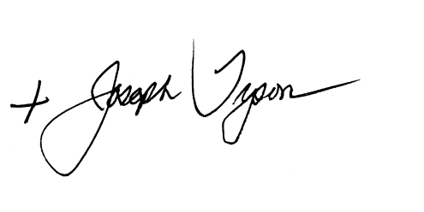

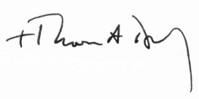

Most Rev. Paul D. Etienne Most Rev. Joseph J. Tyson Most Rev. Thomas A. Daly

Archbishop of Seattle Bishop of Yakima Bishop of Spokane

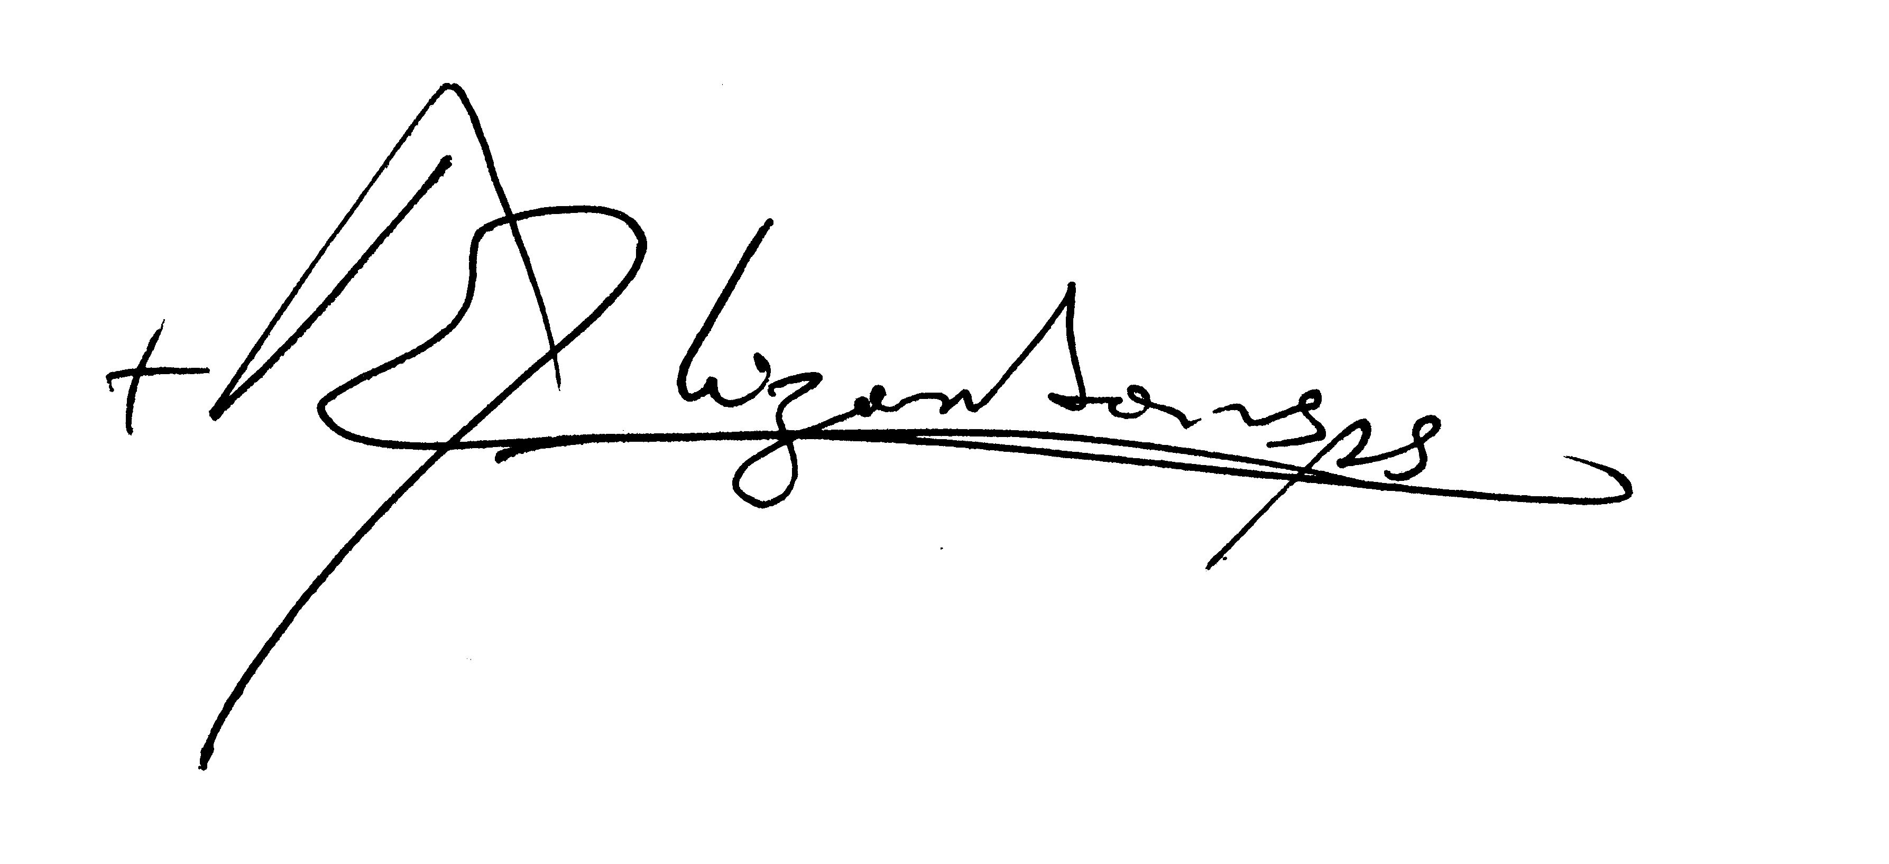



Most Rev. Eusebio Elizondo, M.Sp.S. Most Rev. Daniel H. Mueggenborg

Auxiliary Bishop of Seattle Auxiliary Bishop of Seattle